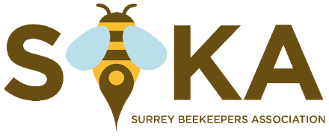

General Data Protection Regulation 2018 (GDPR) Notice

When you joined your local beekeeping association you submitted information allowing us to register you with SBKA, BBKA and Bee Disease Insurance Ltd (BDI) and with BeeCraft Magazine and to allow us to keep in touch with you. We still hold that information for that purpose as you are still a member. In future, a notice will appear on our membership form for new and renewing members explaining how we use the information and notifying of their rights. We are sending this notice to all existing members too :-

“SBKA, through its Divisions, collects and uses your personal data in accordance with the GDPR. Our legal basis for processing this data is our legitimate Interest as a beekeeping association. We use the data for the administration of your membership, the communication of information and the organisation of events, training courses, assessments and exams. We may share it with BBKA, BDI, the BBKA examinations Board and BeeCraft for the purpose of administering your membership requests. We may also share it with HMRC to reclaim the tax if you have submitted a Gift Aid Declaration. More detailed information is on our privacy statement which can be found on our website or from your local membership secretary.”

